Lease and SBITA Retirement Process

Objective: The objective of this file is to provide detailed instructions to state agencies and component units (except MUS) on how to expire leases and SBITAs within the SABHRS AM system. Throughout the rest of this instruction, references to leases also apply to SBITAs.

- Sign in to Asset Management in SABHRS and select Create/View Payable Lease in the menu on the left.

- Enter your business unit and lease number, then click search.

- Select your lease/SBITA that you want to expire.

- Under the Action menu, select Expire Lease and click Go.
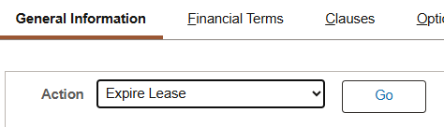

- The Expire Lease reason screen will open. Enter the reason for expiring the lease/SBITA. Usually, this will be due to the expiration of the lease/SBITA. Once the reason is entered, click OK.
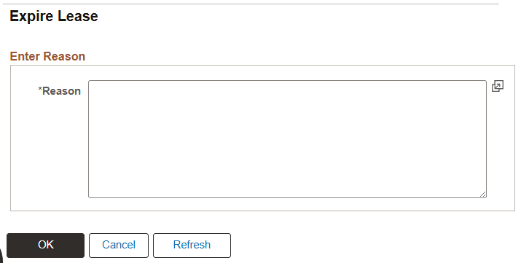

- The following dialog box will appear. Select Yes to expire the underlying asset.
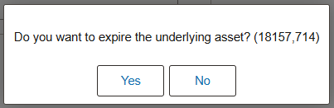

- On the next screen, select Retire Asset. The expiration date on this screen should be changed to the real expiration date that the lease/SBITA was expired.
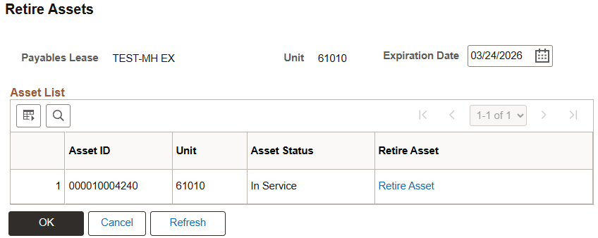

- On the next screen, select Retire As – Retirement by Sale and click Go.
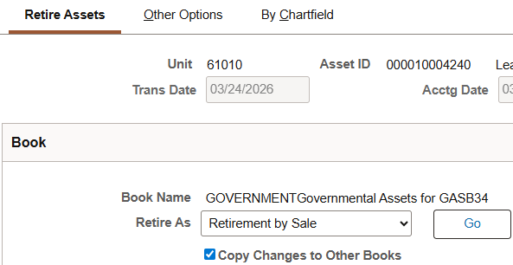

- Once this is done, click Ok at the bottom of the screen.

- It will return you to the Retire Assets screen. Verify that the Asset Status says Disposed.
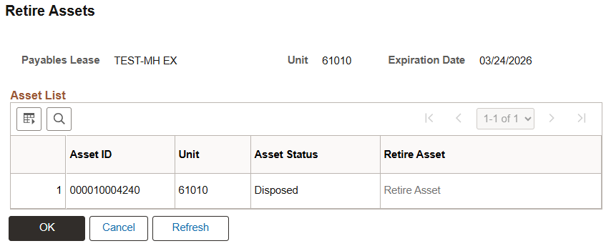

- Click Ok and then click Save.

- Once the retirement process is complete, the Status on the lease screen should say Expired.
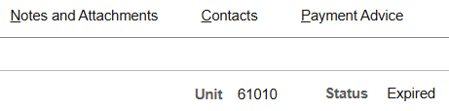

- After the month-end runs, the journal entries related to the lease/SBITA retirement will be posted to the GL by the AM system. AM will generate a RET entry to remove the book value of the retired asset, and if retired early, remove any unpaid lease liability. Agencies need to review the Financial Entries in AM and make GL clean-up entries based on the real situation. The following is an example of a retirement journal for a lease that was retired early, which created a loss:
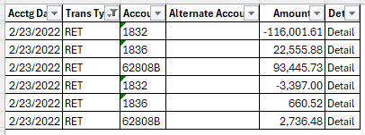

- Complete any cleanup entries if required. Common clean-up entries include:
  - No gain or loss should be recognized but AM generates gain or loss, agencies need to reverse the gain or loss.
  - Because of the timing of retiring a lease, the system may generate amortization and accumulated amortization reversal in the month of retirement, then generate the lease asset retirement with a loss. If the lease is terminated full term, no loss should be recorded. Agencies need to reverse the loss and the amortization reversal to restore the last month's amortization expense.
  - If the lease is early terminated and the lease is not retired in the LA system until the following month, agencies will need to review the journal entries to ensure that amortization is not recorded in the month following termination.

